977-302 Digital Engineering Project I
Semester 1/2025

Visual Analytics of Control-Flow Graphs with Node-Importance Classification
Project Report
Supasan Muanjit 6530613001
Advisor: Asst. Prof. Dr. Jakapan Suaboot

Assoc. Prof. Dr. Warodom Werapun
Asst. Prof. Dr. Norrathep Rattanavipanon

College of Computing
Prince of Songkla University, Phuket Campus

Project Title Visual Analytics of Control-Flow Graphs with Node-Importance Classification
Author Supasan Muanjit 6530613001
Major Digital Engineering
Academic Year 2024

Abstract

This project explores and visualizes data from a malware memory dump/dataset to identify potential indicators of malicious activity. Using Python libraries such as pandas, matplotlib, and NetworkX/pyvis, we analyze process relationships to uncover patterns associated with malware behavior. The findings from this analysis provide valuable insights into memory forensics and establish foundation for future research, including the integration of machine learning for automated malware detection.
Keywords: Malware detection, Memory dump analysis, Graph visualization, Graph-based analysis, Control flow graph (CFG).

Acknowledgements

I would like to express my gratitude to my advisor, Asst. Prof. Dr. Jakapan Suaboot, for their invaluable guidance and support throughout the data exploration phase of this project. Special thanks to the College of Computing for providing access to the dataset and the necessary resources to conduct this research. Their contributions have been instrumental in the successful completion of this work.

Supasan Muanjit
23 Feb 2025

TABLE OF CONTENTS
Abstract ii
Acknowledgements iii
Chapter 1 Introduction 1
1.1 Overview 1
1.2 Objectives 1
1.3 Scopes 2
1.4 Procedures 2
1.5 Expected Results 5
1.6 Locations 6
1.7 Development Tools 7
Chapter 2 Literature Review/Theory Background 8
2.1 Theory1 8
2.1.1 Memory Forensics 8
2.1.2 Malware Behavior in Memory 8
2.1.3 Visualization Techniques 9
2.1.4 Combining Multiple Techniques 9
2.2 Related works/researches 9
2.2.1 Volatility Framwork 9
2.2.2 Baseline Comparison 9
Chapter 3 Proposed Solution 10
3.1 Software Specification 10
3.2 Methodology 11
3.3 Experiment and Proof of Concept 12
3.3.1 Data visualize with NetworkX 12
3.4 Database Design 14
3.5 Project Plan 16
Chapter 4 Results and Conclusion 18
4.1 Results of Visualizations 18
4.2 Conclusion 21
References 22
LIST OF FIGURES

Figure 3. 1 System Architecture 11
Figure 3. 2 Python Code for convert pkl to json. 12
Figure 3. 3 Running Script 13
Figure 3. 4 Visualization node 13
Figure 3. 5 pyvis Graph Visualization. 13
Figure 3. 6 JSON format 15
Figure 3. 7 JSON format convert from Bodmas 15
Figure 4. 1 Comparative Control Flow Graph Visualization of Malware. 19
Figure 4. 2 Visualization of Shared and Unique Control Flow Structures 20

LIST OF TABLES
Table 3. 1 Schedule Plan for Project I. 16
Table 3. 2 Schedule Plan for Project II. 17

LIST OF ABBREVIATIONS
Abbreviation | Full Form
DLL | Dynamic Link Library
CFG | Control Flow Graph
CSV | Comma-Separated Values
GUI | Graphical User Interface
RAM | Random Access Memory
ID | Identifier
OS | Operating System
VM | Virtual Machine
JSON | JavaScript Object Notation
GPU | Graphics Processing Unit
CPU | Central Processing Unit
ML | Machine Learning
IoT | Internet of Things

Chapter 1 Introduction

1.1 Overview
This project focuses on automating malware process identification by analyzing memory dump datasets obtained from infected systems. Utilizing memory forensics tools such as the Volatility Framework, it extracts vital system artifacts including process lists, DLL information, and handles. These artifacts serve as a foundation for exploratory data analysis and visualization.
Advanced graph-based analysis is employed by constructing Control Flow Graphs (CFGs) that represent the execution flow in processes. To improve malware and benign behavior distinction, the project designs a mock CFG generator that samples connected subgraphs from malware CFGs and appends synthetic branching structures to create realistic benign counterparts. This approach enables effective visual comparison of malware and mock CFGs through interactive network graphs, highlighting shared and unique code paths with intuitive color coding.
The project leverages Python libraries including NetworkX for graph processing and pyvis for interactive visualization. These techniques provide deep insights into malware behavior through structural differences in control flows, facilitating enhanced memory forensics and paving the way for integration with machine learning methods for automated malware classification.

1.2 Objectives
The primary objective of this project is to develop an automated system capable of identifying and analyzing potentially malicious processes through comprehensive examination of memory dump data. To achieve this goal, the project focuses on the following objectives:
- Utilize the Volatility Framework to extract critical runtime artifacts including process metadata, loaded DLLs, and handles from Windows memory dumps for forensic analysis.
- Convert and structure extracted data into flexible JSON formats amenable to automated parsing, filtering, and visualization.
- Develop graph-based visualization models using Python tools such as NetworkX and pyvis to represent relationships and control flow graphs, highlighting abnormal or suspicious behaviors.
- Create a realistic mock CFG generator to augment analysis by simulating benign process flows, enabling effective comparative visualization for anomaly detection.
- Provide interactive visualization capabilities with color-coded differentiation to assist analysts in identifying common, unique, and suspicious program behaviors.
- Lay the foundation for integrating machine learning and advanced analytic techniques to support automated malware classification and enhance digital forensic investigations.

1.3 Scopes

This project is focused on analyzing memory dumps acquired from Windows-based operating systems, specifically Windows 10 and Windows 11 the system operates in a post-mortem forensic context, where a static memory image has already been captured and is available for offline analysis the core functionality involves extracting process-related artifacts and metadata using the Volatility 3 framework. Volatility 3 enables comprehensive memory analysis through its modular plugin design without requiring system profiles the project further processes and visualizes this data using Python libraries such as NetworkX and matplotlib to construct and render interactive graphs representing process relationships and control flow. Basic heuristic detection rules are applied to identify suspicious behaviors Although current visualization supports essential analysis, this work does not yet incorporate statistical clustering, advanced supervised learning models, or kernel-level forensic features. However, the system is designed with modularity to allow future integration of machine learning techniques for automated malware classification the intended use case supports early-stage malware triage and visual exploration of memory-based artifacts by digital forensic investigators and cybersecurity researchers.

1.4 Procedures for Acquire Visualize Graph
The project follows a systematic set of procedures to achieve automated malware process identification and analysis:
- Memory Dump Acquisition
Memory images are acquired from Windows 10 and Windows 11 systems in a post-mortem forensic context. The dumps are assumed to be pre-captured and made available for offline analysis.
- Memory Artifact Extraction
The Volatility 3 framework is employed to extract process-related artifacts and metadata from the memory dumps. This includes retrieving process lists and associated control information necessary for further analysis.
- Control Flow Graph Construction
Extracted process information is used to construct Control Flow Graphs (CFGs) using the NetworkX Python library. These graphs visually represent the execution flows and relationships between code blocks within processes.
- Mock CFG Generation
A synthetic mock graph generator samples connected subgraphs from malware CFGs and appends additional branching structures to mimic benign program behavior. This mock data serves as a baseline for comparison and anomaly detection.
- Graph Visualization
The pyvis library is utilized to create interactive, browser-based visualizations of the CFGs and mock CFGs. Color coding differentiates shared and unique nodes and edges between malware and mock graphs for intuitive visual exploration.
- Heuristic Analysis and Interpretation
Basic heuristic rules are applied to identify suspicious nodes or edges within the graphs. Analysts use these visualizations to visually triage malware evidence and guide further investigation.
- Modular Design for Future Extension
The system architecture promotes modularity, allowing integration of advanced statistical, clustering, and machine learning models for automated malware classification in future work.
These procedures collectively form the core of the system and ensure consistent, reproducible analysis for memory-based malware detection.

1.5 Anticipating outcomes
The expected outcome of this project is the successful implementation of a system that can extract, structure, and visualize process and dynamic library information from Windows memory dumps. The system should enable investigators to rapidly interpret runtime behavior and identify potential indicators of compromise through visual inspection and basic heuristic analysis.
Specifically, the project is expected to achieve the following results:
- Memory Artifact Extraction
Successful extraction of critical process-related metadata from Windows 10 and 11 memory dumps using the Volatility 3 framework, providing a solid dataset for downstream analysis.
- Control Flow Graph Generation
Construction of accurate, comprehensive Control Flow Graphs (CFGs) that reflect the execution paths within malware samples, enabling structural analysis of program behavior.
- Mock CFG Generation
Creation of realistic mock CFG datasets that simulate benign code flow by sampling and extending malware CFG subgraphs, offering effective baselines for comparative analysis.
- Interactive Graph Visualization
Development of an intuitive, interactive visualization interface that allows analysts to explore CFGs and their differences using clear color coding to distinguish shared and unique graph components.
- Heuristic Anomaly Detection
Implementation of basic heuristic rules to identify suspicious nodes and execution edges supporting early malware triage.
- Foundation for Automatic Classification
A modular system design that supports future enhancement with machine learning techniques, enabling eventual automated malware process classification based on graph features.
- Practical Forensic Insight
Providing cybersecurity researchers and digital forensic investigators with visual tools to better understand complex malware behavior from static memory images.
The system is intended to serve as a foundational tool for memory-based malware triage, enhancing visibility into process behavior and supporting informed decision-making in digital forensic investigations.

1.6 Locations

- Prince of Songkhla University Phuket Campus

1.7 Development Tools
Hardware
- Laptop Lenovo Legion Y530
Software
- Visual Studio Code/ Jupyter Notebook
- Microsoft Word
- Microsoft Excel
- Volatility 3 Framework
- Python
- NetworkX
- pyvis
- Matplotlib
- Tkinter
- Linux (Arch) and Windows 11

Chapter 2 Literature Review/Theory Background

2.1 Malware Analysis Technique
Memory forensics is a critical component of cybersecurity, focusing on the analysis of volatile memory (RAM) to detect and investigate malicious activity. Unlike traditional disk-based forensics, memory forensics provides real-time insights into the runtime behavior of processes, making it particularly effective for detecting advanced threats like fileless malware and in-memory attacks. Below are the key theoretical concepts relevant to this project

2.1.1 Memory Forensics
Memory forensics [1] involves extracting and analyzing data from a system's RAM to identify malicious activity Key such as:
- Process Lists: Information about running processes, including process IDs, parent process IDs, and process names.
- DLLs (Dynamic Link Libraries): Libraries loaded by processes, which can reveal malicious behavior if rare or unusual DLLs are used.
- Handles: Connections to system resources such as files, registry keys, and network sockets, which can indicate suspicious activity.

2.1.2 Malware Behavior in Memory
Malware often exhibits specific behaviors [2] in memory, such as:
- Orphaned Processes: Processes with no parent process, which are often created by malware to evade detection.
- Rare DLLs: Malware may load uncommon or malicious DLLs to execute its payload.
- Sensitive Handles: Malware may open handles to sensitive system resources, such as registry keys or system files, to manipulate the system.

2.1.3 Visualization Techniques
Visualization [3] plays a crucial role in memory forensics by transforming complex data into intuitive graphs and charts. Common visualization techniques such as:
- Network Graphs: To show relationships between processes (e.g., parent-child relationships).
- Heatmaps: To visualize the frequency of DLL usage across processes.
- Pie Charts: To display the distribution of handle types (e.g., file, registry, mutex).

2.1.4 Combining Multiple Techniques
Combining multiple analysis techniques [4] (e.g., process analysis, DLL analysis, handle analysis) improves the accuracy of malware detection. This approach reduces false positives and provides a more comprehensive understanding of malicious behavior.

2.2 Related works/researches

2.2.1 Volatility Framwork
A. Huseinović and S. Ribić (2014) [1] work for investigated memory forensics in virtualized environments, emphasizing the importance of tools like Volatility Framework for extracting process lists, DLLs, and handles. Their work provides a foundation for understanding how memory forensics can be used to identify malware indicators.

2.2.2 Baseline Comparison
Akash Thakar et al. (2023) [4] work for proposed an enhanced malware detection method using baseline comparison in memory forensics. Their approach compares the behavior of processes in a memory dump to a known baseline of normal behavior, which aligns with our project’s focus on identifying anomalies.

Chapter 3 Proposed Solution
In this chapter, the project developer will go over the software specification, methodology, experiment proof of concept and project plan.

3.1 Software Specification
The development of this project is supported by a range of software tools selected for their compatibility with forensic analysis workflows, flexibility in data processing, and support for graph visualization. The following software components were utilized:
- Volatility 3 Framework
  - Purpose: Memory dump analysis and extraction of system artifacts.
  - Platform: Cross-platform (used on Linux).
  - Version: 2.11.0 – 2.26.2 (Git-based development version).
  - Role: Primary tool for executing plugins such as pslist, dlllist, and malfind on Windows memory dumps.
- Python 3.13
  - Purpose: Core scripting language for data parsing, analysis, and visualization logic.
  - Platform: Cross-platform (developed on Arch Linux and Windows 11).
  - Libraries used: json, matplotlib, networkx, collections, tkinter.
- Matplotlib
  - Purpose: Static graph rendering for process–DLL relationship visualization.
  - Backend: TkAgg for GUI display.
- NetworkX
  - Purpose: A comprehensive Python library for the creation, manipulation, and study of the structure and dynamics of complex networks. Used here for constructing Control Flow Graphs (CFGs)

- Pyvis
  - Purpose: Utilized for generating interactive network visualizations in HTML format. The library supports graph exploration through zooming, panning, and dynamic node colors.
- Jupyter Notebook and VS Code
  - Purpose: Code prototyping, testing, and script development.
- Operating Systems
  - Development and testing were conducted on both Arch Linux and Windows 11, ensuring platform compatibility and reproducibility.

3.2 Methodology
Our process consists of the 4 steps in terms of techniques and methodology (see Fig 3.1)
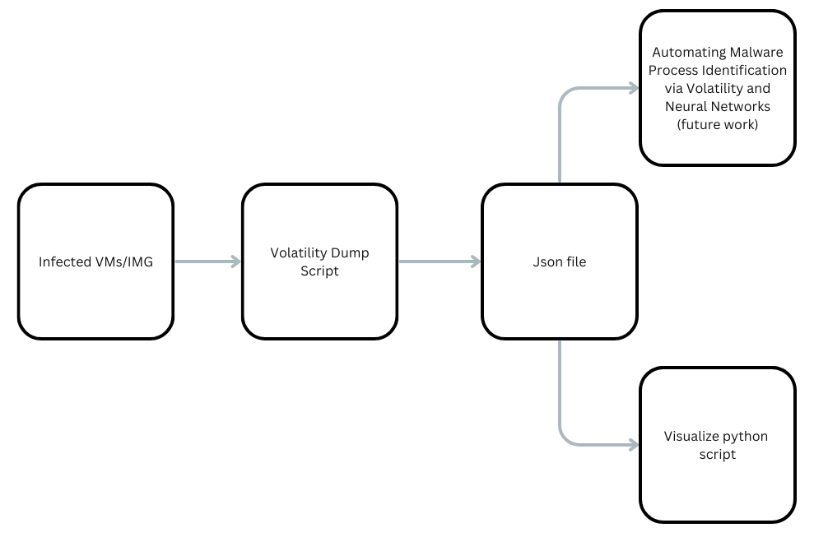
Figure 3. 1 System Architecture

First, memory dump files from malware-infected systems are collected, ensuring the dataset includes process IDs, parent process IDs, DLLs, and handles. The data is then preprocessed to clean and structure it for analysis. Using the Volatility Framework, process lists are analyzed to identify orphaned processes and unusual DLL relationships, which are visualized using a network graph/pyvis.

3.3 Experiment and Proof of Concept

3.3.1 Data visualize with NetworkX
The project utilizes NetworkX, a versatile Python library for creating, manipulating, and analyzing complex networks, to visualize process control flow graphs (CFGs) generated from memory dump data. In this context, nodes represent basic blocks or program segments, and edges indicate control flow transitions between these blocks. NetworkX provides a rich set of features to construct detailed graphical representations, apply layout algorithms (such as spring or circular layouts), and customize node/edge attributes for clarity. This approach allows clear visualization of malware and mock CFGs to reveal structural execution patterns, aiding in behavioral analysis and forensic investigation. When combined with interactive visualization libraries like pyvis, NetworkX becomes a powerful tool for enabling exploratory data analysis and effective visual comparison.

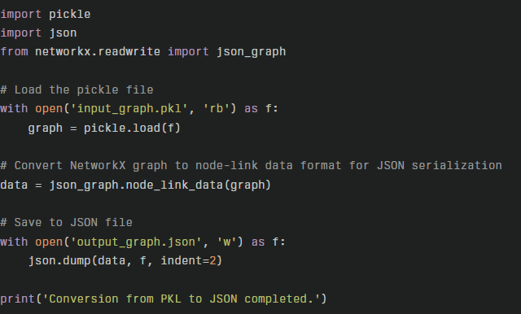
Figure 3. 2 Python Code for convert pkl to json.

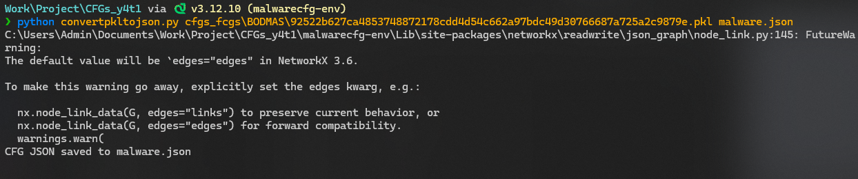
Figure 3. 3 Running Script

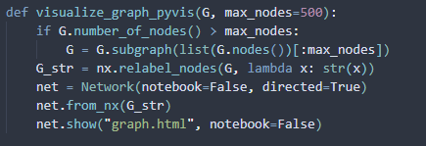
Figure 3. 4 Visualization node

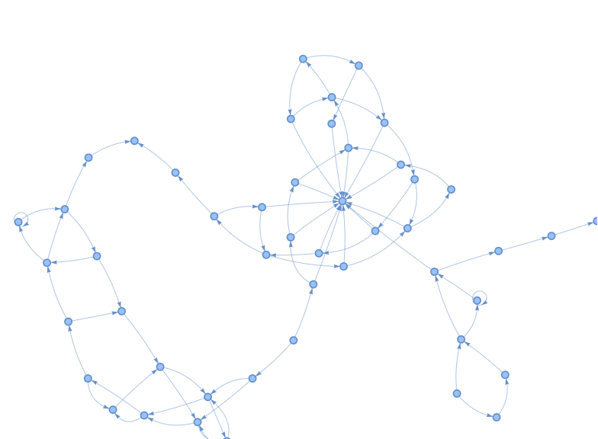
Figure 3. 5 pyvis Graph Visualization.
Figure 3.5 displays the initial visualization of the graph data using pyvis, providing a comprehensive preview of the structure prior to any comparative analysis. This figure allows investigators to inspect the overall topology, node connectivity, and distribution within the dataset before applying further analytical techniques. By reviewing this visualization, analysts are able to identify key regions, potential structural anomalies, and assure that the graph has been correctly processed and loaded into the visualization pipeline. Explicitly referring to Figure 3.5 in the report ensures that readers understand the purpose and context of each visual asset within the workflow.

3.4 Database Design
This project does not employ a traditional relational database system. Instead, it utilizes structured JSON files generated from memory dump analysis. Unlike typical outputs from Volatility 3 plugins such as dlllist, the dataset used in this work is sourced from the Bodmas dataset, which provides enriched and pre-processed data tailored for control flow and malware behavior analysis the Bodmas dataset contains detailed graph representations of program control flows captured from malware samples, encapsulated in JSON format. Each JSON record captures node and edge attributes relevant to control flow graphs (CFGs) rather than solely process-DLL metadata. This includes function addresses, instruction counts, branch types, and connectivity information vital for constructing accurate CFGs these JSON files are parsed and processed using Python libraries, supporting flexible filtering, heuristic evaluations, and interactive visualization without requiring a persistent database. This structured data source provides greater specificity and suitability for graph-based malware analysis pipelines compared to more generic plugin outputs by leveraging the Bodmas dataset, the project benefits from richer structural information enabling advanced graph analytical techniques and effective visualization of malware execution patterns.

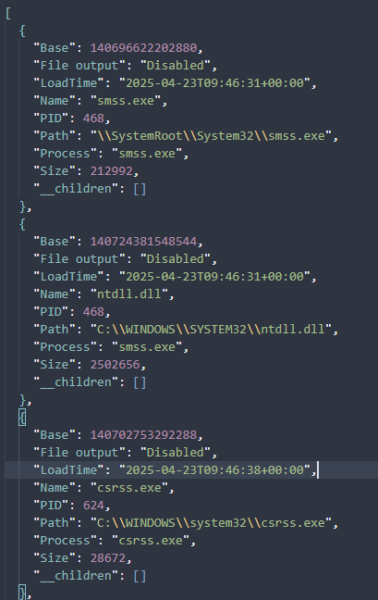
Figure 3. 6 JSON format

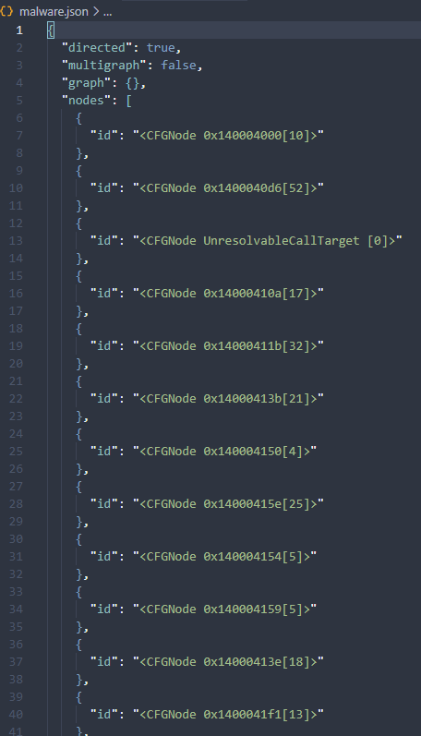
Figure 3. 7 JSON format convert from Bodmas

3.5 Project Plan

Table 3. 1 Schedule Plan for Project I.
Task | 2025
Task | January |  |  |  | February |  |  |  | March |  |  |  | April |  |  |  | May
Task | 1 | 2 | 3 | 4 | 1 | 2 | 3 | 4 | 1 | 2 | 3 | 4 | 1 | 2 | 3 | 4 | 1 | 2 | 3 | 4
research and education.
Requirement Gathering and Planning.
Tool Selection and Design.
Implement Prototype.
Testing and Improvement.
Final Prototype.

Table 3. 2 Schedule Plan for Project II.

Task | 2025
Task | August |  |  |  | September |  |  |  | October |  |  |  | November |  |  |  | December
Task | 1 | 2 | 3 | 4 | 1 | 2 | 3 | 4 | 1 | 2 | 3 | 4 | 1 | 2 | 3 | 4 | 1 | 2 | 3 | 4
Research and Education.
Requirement Gathering and Planning.
Tool Selection and Design.
Improve Prototype.
Testing and Improvement.
Script and interactive visualize.

Chapter 4 Results and Conclusion

4.1 Results of Visualizations
The visualizations produced by integrating NetworkX and pyvis provide comprehensive insights into malware behavior as observed through memory dump analysis. The Control Flow Graphs (CFGs) successfully model the complex execution paths of malware samples, highlighting nodes (basic blocks) and edges (control flow transitions) that represent program logic structures.
By generating and comparing mock CFGs alongside malware CFGs, the interactive visualizations effectively differentiate shared and unique code regions. Color-coding enhances interpretability, with red highlighting nodes and edges common to both graphs, blue representing mock-only paths, and green indicating malware-specific control flows.
The ability to zoom, pan, and interactively explore the graphs allows analysts to identify suspicious execution patterns and isolate potentially malicious code clusters. These features support early-stage malware triage by providing readily interpretable visual evidence.
Overall, the results demonstrate that graph visualization is a powerful tool to complement memory forensic analysis, enabling cybersecurity practitioners to unravel complex malware behavior in a structured and user-friendly manner.

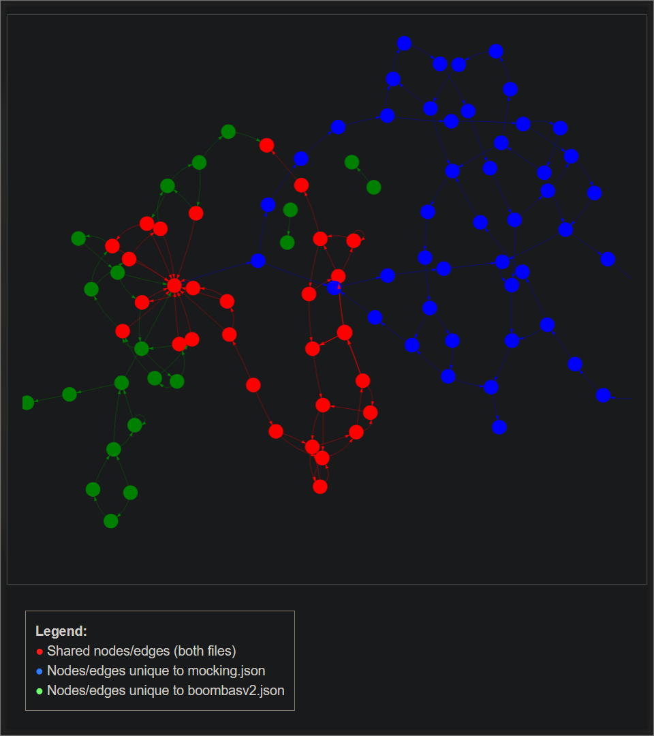
Figure 4. 1 Comparative Control Flow Graph Visualization of Malware.
Figure 4.1 illustrates the comparative control flow graph visualization generated from two datasets: boombasv2.json (malware data) and mocking.json (benign mock data). In this image, shared nodes and edges between both datasets are represented in red, nodes and edges unique to the mock data are blue, and those unique to the malware dataset are green. This visualization enables the clear identification of overlapping and distinct code pathways between benign and malicious samples, providing structural insight crucial for further analysis. By explicitly referring to Figure 4.1, the report demonstrates how graphical comparison supports the workflow of anomaly detection and informed forensic investigation.

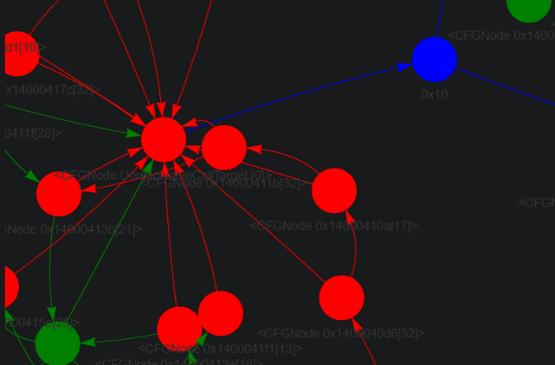
Figure 4. 2 Visualization of Shared and Unique Control Flow Structures
Figure 4.2 presents a detailed segment of the comparative control flow graph, emphasizing the structural relationships among shared, mock-unique, and malware-unique nodes and edges. In this visualization, red nodes and edges represent elements common to both datasets, while green and blue highlight the areas unique to the malware and mock graphs, respectively. This close-up view enables analysts to focus on key overlapping regions and discern how control flow diverges between benign and malicious samples. Explicitly referring to Figure 4.2 clarifies its role, demonstrating how targeted visualization facilitates identification of critical differences and suspects in the malware structure. This figure is essential for interpreting graph topology and supporting fine-grained forensic assessment of memory artifacts.

4.2 Conclusion
This project successfully demonstrates an automated approach to malware process identification through comprehensive memory dump analysis and graph-based visualization techniques. By leveraging the Volatility 3 framework and the Bombas dataset, enriched with control flow data, the system enables detailed reconstruction and comparison of malware execution paths in the form of Control Flow Graphs (CFGs).
Interactive graph visualizations using NetworkX and pyvis facilitate intuitive exploration of complex malware behaviors, highlighting shared and unique structural elements compared to mock benign graphs. Basic heuristic methods incorporated into the workflow support early-stage triage and anomaly detection, providing practical benefits to digital forensic investigators and cybersecurity analysts.
The modular design of the system promotes extensibility for future integration of advanced machine learning and statistical models, paving the way for automated and scalable malware classification. Overall, this work contributes valuable tools and methodologies to the cybersecurity community for enhanced analysis and detection of sophisticated malicious software within volatile memory.

References

[1] |  | A. Huseinović and S. Ribić, "Virtual machine memory forensics," 2014.
[2] |  | A. Afreen, M. Aslam and S. Ahmed, "Analysis of Fileless Malware and its Evasive Behavior," in 2020 International Conference on Cyber Warfare and Security (ICCWS), Islamabad, Pakistan, 2020.
[3] |  | M. Ficco, "Malware Analysis by Combining Multiple Detectors and Observation Windows," IEEE Transactions on Computers, vol. 71, pp. 1276 - 1290, 2021.
[4] |  | Akash Thakar; Rakesh Singh Kunwar; Hemang Thakar; Kapil Kumar; Chintan Patel, "Enhanced Malware Detection Method Using Baseline Comparison in Memory Forensics," in 2023 IEEE 11th Region 10 Humanitarian Technology Conference (R10-HTC), Rajkot, India, 2023.
[5] |  | Hesamodin Mohammadian, Explainable malware detection through integrated graph reduction and learning techniques, 2025.
[6] |  | "Bodmas Dataset.A Dataset for Malware Control Flow Analysis and Visualization," 2024.

